**­­**

**Eligibility criteria**

* **Enrolled in undergraduate program in biomedical engineering or any life science discipline.**
* **Master’s degree students who are interested to pursue their career in research.**
* **And open for all research scholars.**

**Accommodation**

**Boarding & Lodging can be made available at nominal cost with advance booking.**

**Limited accommodation for outstation participants.**

**Important dates**

**Deadline for registration: 01.08.2019**

**Selection notification through E-mail: 08.08.2019**

**Registration fee for outside participants:Rs.300.**

**Registration can be done via**

***https://forms.gle/aA545RJLokwB3wRQ7***

**Selection process**

**The course is aimed for maximum of forty participants. Selection to the program is based on their academic and research record.**

**Project Expo**

**You are most welcome to display your projects relevant to this topic. Best projects will be awarded.**

**Contact details**

**Ms. M. Bobby - 9994214158**

**Mrs. C. Pon Selvi - 9994960490**

**bobby.m@rajalakshmi.edu.in**

[**ponselvi.c@rajalakshmi.edu.in**](mailto:ponselvi.c@rajalakshmi.edu.in)

**Chief Patron**

**Dr. (Mrs) Thangam Meganathan,**

**Chairperson.**

**Patron**

**Dr. S. N. Murugesan**

**Principal.**

**Convenors**

**Dr. R. Kalpana**

**Professor and Dean**

**Dr. S. Rajkumar**

**Professor and Head**

**Dr. B.S. Suresh Anand**

**Associate professor.**

**Faculty Organizers**

**Ms. M. Bobby, AP/BME**

**Mrs. C. Pon Selvi, AP/BME**

INNOVATION distinguishes between a leader and a follower

* Steve Jobs



**Engineering Solution to Clinical Needs: Research and Innovation**

**Supported by**

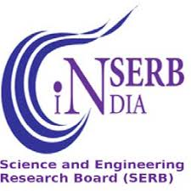

**20 – 21 August 2019**

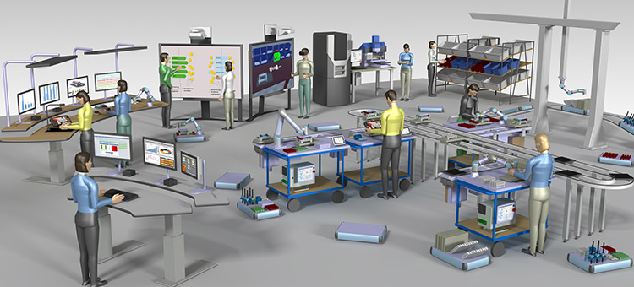

**Organised by**

**Department of Biomedical Engineering**

**Rajalakshmi Engineering College**

**Thandalam, Chennai- 602105**

**Website: www.rajalakshmi.org**



**About the institution**

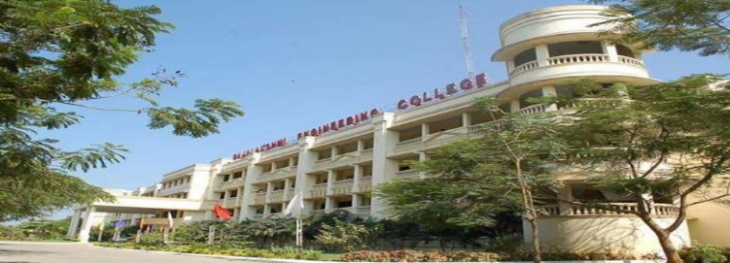

**Rajalakshmi Engineering College, an autonomous institution affiliated to Anna University, Chennai, was established in the year 1997 under the aegis of Rajalakshmi Educational Trust whose members have had consummate experience in the fields of education and industry. The College has grown from strength to strength in the last 20 years and progressing towards Excellence in Engineering Education, Research and Development.** **Started with 3 Under Graduate programmes in Engineering with an annual intake of 180 students in 1997, the College presently offers 12 Under Graduate and 10 Post Graduate programmes, with an annual intake of 1950 students.**

**About the Department**

**Biomedical Engineering is the application of Engineering concepts and techniques in the field of Medicine. It combines the problem solving capability of engineers with the medical expertise of physicians to enhance the quality of life through health care process. Biomedical engineers bridge the medical and engineering disciplines to provide an overall enhancement in the quality of health care and products.** **Rajalakshmi Engineering College has established the Department of Biomedical Engineering in the year 2006.**

**About the program**

**Engineering and technology has greatly revolutionized medical field especially clinical translation has provided solution to many health related problems. This seminar is to focus the problems in terms of diagnosis, localisation, prenatal diagnosis, intra operative monitoring and alternative medicine with present scenario and to show a guideline to the research scholars based on clinical observation, academicians’ opinion from their finding and from market survey. At the end of this workshop, participants can work on multi directional and multi disciplinary integration of basic research with a long term aim of improving overall public health and quality of life.**

**Course topics**

* **Statistics and critical review on various healthcare problems.**
* **Way to engineering solution and deployment procedure.**
* **Clinical observation with an emphasis on quality enhancement.**
* **Medical product development**
* **Ethical issues and safety regulations**
* **Hands on related soft skill.**
* **Visit to medical industry and multi-specialty hospital.**

**Engineering Solution to Clinical Needs: Research and Innovation**

**20 – 21 August 2019**

**REGISTRATION FORM**

**Name: _________________________________**

**DOB: __________________________________**

**Gender: Male / Female**

**Designation: ____________________________**

**Department: ____________________________**

**Institution: _____________________________**

**Address: _______________________________**

**_______________________________________**

**Phone: ____________Mobile: ______________**

**E-mail:_________________________________**

**Accommodation required: Yes / No**

**DECLARATION BY THE CANDIDATE:**

**The given information is true to the best of my knowledge. I agree to abide by the rules and regulations governing the programme. If selected, I shall attend the course for the entire duration.**

**Date:**

**Place:**

**Signature of the Participant**

**The best place for Technological Innovation to explore…!**